Problem with common names:
•
_________________ - study of classifying organisms
_________________are scientists who study classifying
____________( taxa-plural) is a category into which related organisms are placed
Why do we need a system of classification?
- ________________
- logical means of naming organisms
- scientific names are understood ________________

______________
divided organisms into two groups
____________: classified them on the basis of structure and size
____________: subdivided them on the basis of where they live

__________________
Swedish botanist who developed a classification system based on structural
features.
seven taxa
-
-
-
-
-
-
-
A sentence to help remember these taxa is
binomial system of nomenclature, in which the _________and _________names are used.
Each species has a single correct scientific name in Latin called a binomial (two names) – it is always italicized or underlined.
First name is _________name.
Second name is _________name
Human: Homo sapiens Cat: Felis catus Dog: Canis familiaris Wolf: Canis lupus
4 Basis for Modern taxonomy:
Modern taxonomists classify organisms based on their evolutionary relationships
1. _________________________________have the same structure, but different
functions & show common ancestry.
The bones in a bat's wing, human's arm, penguin's flipper are the
same (homologous), but the function is different
2. _________________________________ have the same function, but different
structures & do not show a close relationship (insect wing & bird's wing)
3. __________________________________________ shows a close relationship
(vertebrate embryos all have tail & gill slits)
4. _________________________________________sequences of proteins show
related organisms
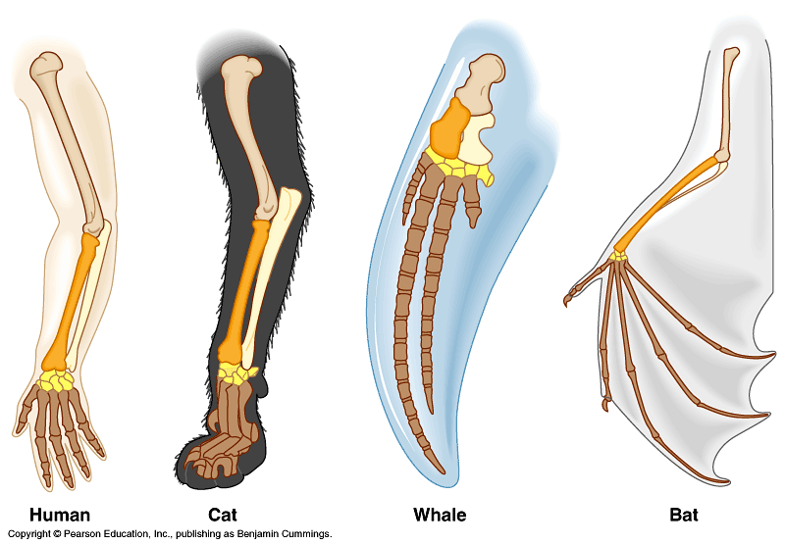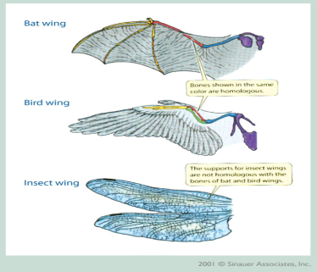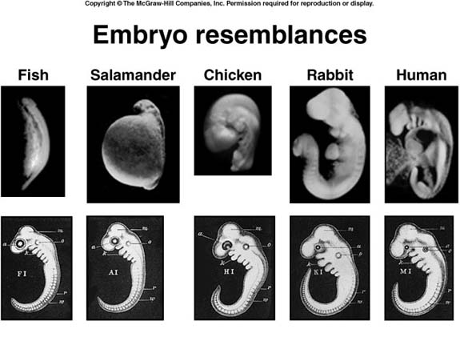
6 Kingdoms
- -
- -
- -

________________: a set of individuals that are closely related by descent from a common ancestor and ordinarily can reproduce with each other, but not with members of any other species.
Evolution
A ___________________in a population of organisms that occurs over time, often adapting to an environment or way of life.
Evolutionary changes must be genetically___________________, not acquired.
- _________________holds that traits acquired (or diminished) during the lifetime of an organism can be passed to its offspring.
- Darwin changed biological thought forever with the concept of _____________________
Natural Selection has four premises:
1) __________________– Members of a population have individual differences that are _____________
2) _____________ – Natural populations reproduce more than can be supported
3) ______________– Individuals compete for limited resources
4) _______________________– Only those individuals that are better suited to the environment survive and reproduce

Natural Selection
- ___________ – long periods of time must be available in order to change to a completely different species; changes are slow..
- Offspring that inherit the advantageous traits (“favorable genes”) have greater chances of survival. They may live to reproductive age and pass on those desirable attributes to future generations.
- Those that do not inherit these traits (“unfavorable genes”), are not likely to survive/reproduce.
- Gradually, the species evolves (changes) as more individuals carry these traits.
- Over time, enough changes New species
Artificial Selection
-
-
Mechanisms of evolution
- 1.___________________: produce new alleles and new genes.
  - are random
  - cannot be predicted ahead of time
  - create genetic variety
  - may be beneficial, neutral, or harmful to the individuals that inherit them
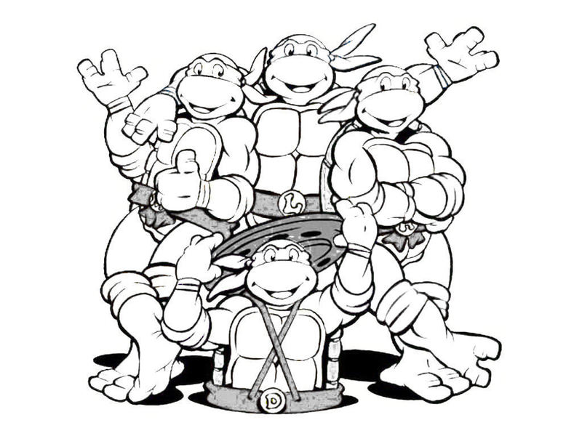

2. __________________(immigration/emigration).
  - Technical term is ______________.
  - The movement of alleles between populations as a result of movement of individuals from one population to another.
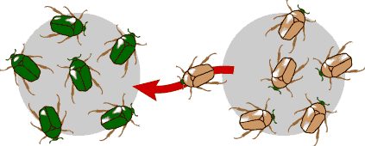
3. ______________________: when chance, rather than traits determine reproductive success. Example: disaster that kills part of a population. Small populations are more susceptible to big evolutionary change due to chance. Technical term is _____________________.
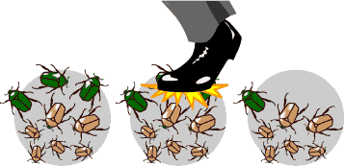
4.____________________: When traits determine reproductive success; traits in more reproductively successful individuals get passed on more into the next generation.
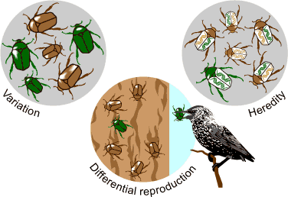
Sexual Selection
- selection caused by _____________of females for male traits, or vice versa
- explains some extreme male characteristics which do not make them more successful
- Examples ________________ and _______________________

Types of Evolution
1. ________________evolution
- Two ____________populations of a species that experience ________________ pressures may as a result become genetically different from one another
- Once in a very great while, the two populations will become so different that they ______________________together anymore (this then becomes speciation).
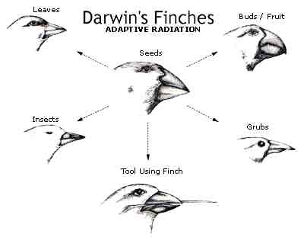
Formation of species –

_________________________= a population is divided by a geographic barrier (e.g. river, mountain range)
_________________________ = a population is divided by an ecological barrier (e.g. feeding or breeding in different places)
- 2. ____________________ evolution
- Start with two very different species; they experience _________________ pressures and through time come to look and/or behave similarly.
Many plants look like cacti because they also have evolved to store and defend water but they are not cacti
Lens eyes exist in vertebrates, many molluscs, some medusas, some annelids, and some cephalopods
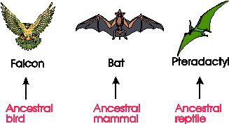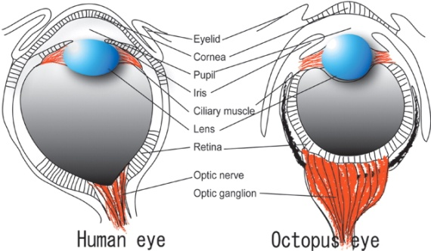
________________________= minor changes in organisms (eg. variation in beak depth in Darwin’s finches)
_____________________ = major changes in organisms (eg. monkeys to humans)
Rates of evolution
1. _____________________ (a traditional view) states that Evolution occurs as a slow and steady accumulation of changes in organism.
2. ________________________– evolution proceeds with periods of inactivity, followed by periods of very rapid evolution.
