Some prokaryote facts
- prokaryotes are the oldest organisms on Earth and evolved alone for 1.5 billion years
- their combined weight is at least ten times that of all eukaryotic cells in the world combined
- there are more prokaryotes in the mouth of a human than the total number of people who have ever lived
- prokaryotes live in places that are too hot, cold, acidic, or basic for other life forms

Characteristics of prokaryotes
- lack a nucleus and other organelles
- all single-celled
- many have a cell wall of peptidoglycan
- have a single, circular chromosome
- reproduce by binary fission and conjugation
- have many different metabolisms
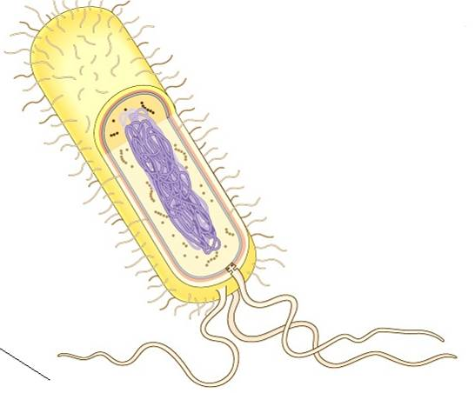
flagella
chromosome
cell membrane
cell wall
pili
ribosome
General anatomy of prokaryotes
chromosome – genetic material, formed in a ring or loop
ribosome – creates protein
flagella – a long whip-like structure used for movement
pili – small structures used for attachment, not movement
cell wall – made of peptidoglycan
peptidoglycan = protein found in the cell wall of prokaryotes
cell membrane – a semi-permeable membrane like that of other cells
There are two kinds of cell wall:
- Gram positive
- cell wall outside the cell membrane
- high peptidoglycan content
- Gram negative
- have a second membrane outside a thin cell wall – less peptidoglycan
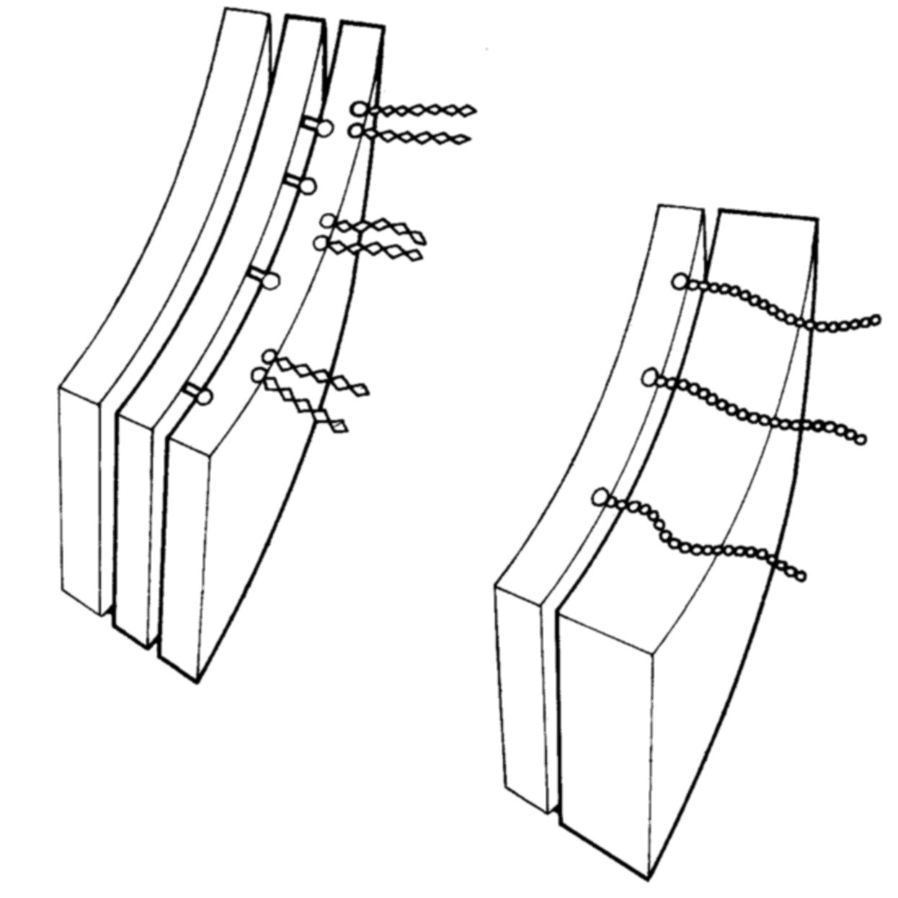
gram positive cell wall
cell membrane
cell wall
gram negative cell wall
cell membrane
cell wall
outer membrane
Prokaryote shapes
- prokaryotes are always unicellular, they live as individual cells
- some will join together, but these are not truly multicellular
- prokaryotes come in three basic shapes:
- spheres, called cocci (coccus singular)
- rods, called bacilli (bacillus sing.)
- spiral, called spirilla (spirillum sing.)
bacilli
cocci
spirilla
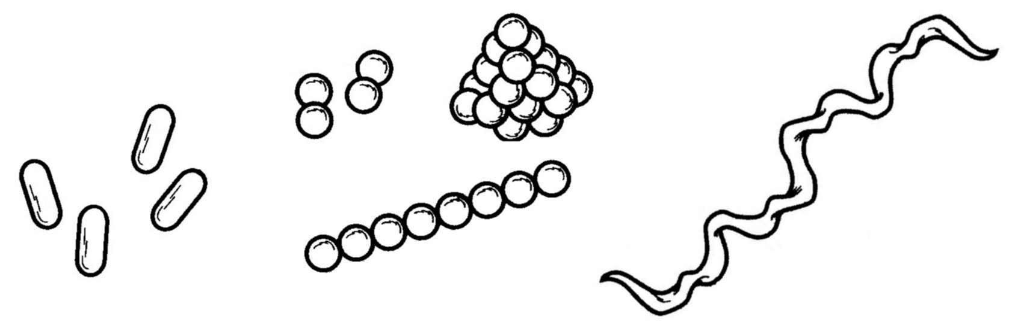

Binary fission
- all prokaryotes reproduce asexually by binary fission – splitting in two
- resembles mitosis, but simpler
- the chromosome duplicates and the cell divides in two
Binary Fission:
Conjugation
- sexual reproduction occurs in some prokaryotes
- small accessory rings of DNA called plasmids are transferred from one cell to another

binary fission
conjugation
single prokaryote
chromosome copied
cell divides
two identical cells
two prokaryotes
bridge forms
plasmid copied
plasmid transferred
chromosome
plasmid

Antibiotics
antibiotic = chemical that kills or slows the growth of bacteria
- first widely used antibiotic was penicillin, a chemical made by the mold Penicillium
- most antibiotics work by preventing formation of peptidoglycan or protein in general
- they are not dangerous to animals

Antibiotic resistance
antibiotic resistance = the ability to withstand the effects of antibiotics
- since their discovery, the usefulness of antibiotics has decreased as prokaryotes adapt
- this is an extreme example of selection: only those with resistance can survive
Metabolism
Organisms require two things to live:
- energy source (perform cell functions)
- carbon source (make organic molecules)
autotrophs = carbon from CO₂
heterotrophs = carbon from organic chemicals

Aerobic vs. anaerobic
aerobic = metabolism with oxygen
anaerobic = metabolism without oxygen
- some prokaryotes are able to tolerate oxygen, others find it poisonous
- fermentation is anaerobic, produces various products (including ethanol)
- our own metabolism is usually aerobic

Photoautotrophs
- energy source is light
- carbon source is CO₂
- some bacteria and archaea (as well as many eukaryotes)
e.g. cyanobacteria or “blue-green algae”

Chemoautotrophs
- energy source is inorganic chemicals
- carbon source is CO₂
- some bacteria, many archaea
e.g. the archaea that live on hydrothermal vents

Chemoheterotrophs
- energy and carbon source is organic compounds (from other organisms)
- found in bacteria, archaea (and many eukaryotes)
e.g. nitrogen-fixing bacteria in plant roots

Metabolism summary:
 | Energy source | Carbon source
Photoautotrophs | Sun | CO2
Chemoautotrophs | Inorganic chemicals | CO2
Chemoheterotrophs | Organic chemicals | Organic chemicals

There are two major kinds of prokaryotes:
- Kingdom Eubacteria
- Kingdom Archaebacteria
- differ from each other in their DNA replication: Archaea are more similar to eukaryotes

Some kinds of Archaea
- methanogens – anaerobic, make methane – live in animal guts, in the Earth’s crust, at hydrothermal vents
- halophiles – extremely salty environments
- hyperthermophiles – extremely hot environments, up to 120 degrees

Most prokaryotes are beneficial
- gut symbionts
- nitrogen-fixing bacteria
- bacteria that clean up oil spills
- bacteria that make food (yoghurt, etc.)

Bacterial pathogens
pathogen = the organism that causes a disease
- some of the worst human diseases are caused by bacteria
- transmitted through air, body fluids, animal bites, or wounds
Bubonic plague (Black Death)
- Yersinia pestis causes the disease – transmitted in the saliva of fleas
- 10’s of millions of deaths in 14th century

Anthrax
- Bacillus anthracis, common in soil, hair of animals, etc.
- direct contact with animals or letters

Leprosy
- Mycobacterium leprae, attacks skin and nerves, eventually causing loss of sensation

Tetanus
- Clostridium tetani, an anaerobic bacterium found nearly everywhere
- causes uncontrollable muscle contraction

Biological warfare
- during the Middle Ages, attacking armies would fling plague infected corpses into castles with catapults
- in WWII Japanese Army released plague fleas on Chinese forces; the attack backfired, infecting both sides
- hypothetical future – genetically engineered superbugs, such as antibiotic-resistant anthrax
Viruses
Characteristics of viruses
- very small (~0.1μm)
- simple structure: genetic material wrapped in protein
- cannot reproduce on their own
- can form crystals

Viruses are made of up to three basic parts:
- genetic material – either DNA or RNA, from 3-100 genes
- capsid – a protective protein coat with a particular shape
- envelope – some viruses steal a portion of the cell’s membrane as an outer layer
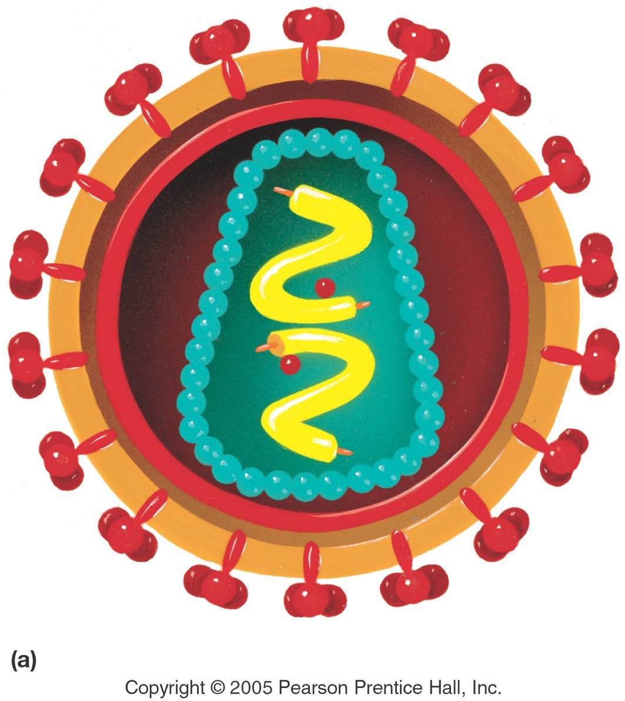
envelope
genetic material
capsid
Virus structure: HIV

Virus shapes
- helical – a hollow cylinder in the shape of a helix (coil)
- polyhedral – a regular shape of many sides, usually an icosahedron (20 sides)
- enveloped – a helical or polyhedral particle surrounded by an envelope
- complex – a wide variety of other irregular shapes

Bacteriophages
- viruses that only infect bacteria
- very specialised shape – like a little moon lander

There are two main kinds of virus reproduction:
- the lytic cycle – destroys the host cell
- the lysogenic cycle – virus goes dormant in host cell before entering lytic cycle

The lytic cycle
- virus inserts its genetic material into a host cell
- genetic material takes over the cell’s activities
- the cell makes parts of future viruses
- viruses assemble and the cell explodes (lysis), releasing them
Examples of lytic viruses:
- common cold
- influenza
- Ebola
The lysogenic cycle
- virus injects genetic material into host
- genetic material is inserted into the host cell’s DNA
- viral genes go dormant for an undetermined length of time, but are copied with the host cell’s DNA
- without warning, the cell will switch into the lytic cycle, releasing many viruses
Examples of lysogenic viruses:
- Herpes
- Hepatitis
- HIV

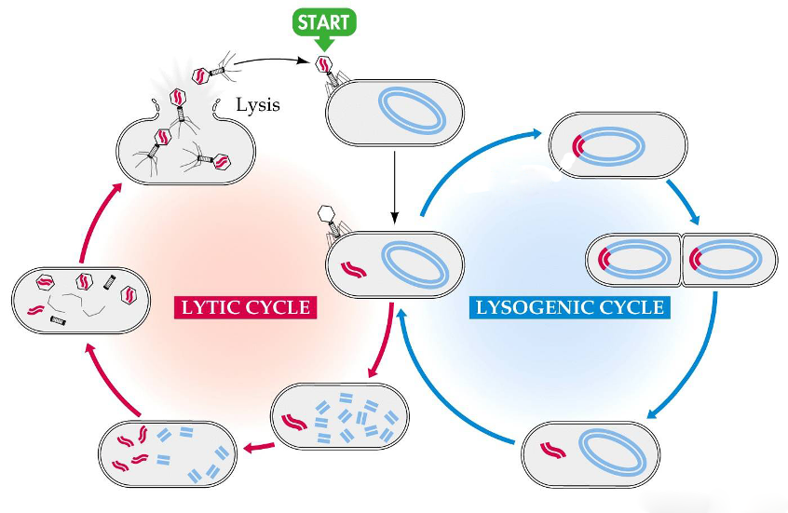
Life cycle summary
Virus enters host DNA
Cell bursts and releases viruses
Viral DNA copied
Viral DNA activates
Virus injects DNA
Virus parts assembled
Viral DNA passed on to other cells
Viruses as pathogens
- viruses need to invade cells to reproduce and so most of them are pathogens
- some viruses cause minor infections, others are fatal
- aside from vaccines, there is no effective medical treatment for viral infection

Viral pathogens in the news
- Severe acute respiratory syndrome (SARS)
- West Nile virus
- bird flu
- Hanta virus
- Human immunodeficiency virus (HIV)

Smallpox
- causes high fever, and the formation of small blisters on skin
- effective vaccine: only viral disease to be ‘completely’ eliminated in 1977

Polio
- transmitted through contact and faeces
- destroys nerve cells, causing paralysis
- probably will be the next viral disease eliminated by vaccine

Hanta virus
- transmitted only through mouse faeces
- flu-like symptoms, eventually lungs fill with fluid
- no vaccine – avoid contact with mice!

West Nile virus
- transmitted from birds to humans through mosquitoes
- causes brain infection (encephalitis)
- no vaccine – avoid contact with mosquitoes

HIV (Human Immunodeficiency Virus)
- destroys the host’s immune system, leaving them vulnerable to other diseases (AIDS)
- transmission through body fluids – estimated 50 million infected worldwide
- no vaccine – there are effective drugs but no cure

Ebola
- first recognised in 1976
- transmitted through contact with body fluids
- symptoms include fever, diarrhea, vomiting, internal and external bleeding
- no vaccine – outbreaks controllable (so far)

Living qualities of viruses:
- Have a protein coat (capsid)
- Some have special proteins
- Have a small amount of genetic material
Non-living qualities of viruses:
- Non-cellular
- Do not grow
- Do not make or use energy
- Do not respond to their environment
- Cannot reproduce on their own
- Can be crystallised

Q: Are viruses alive?
- viruses require cells to reproduce, and are not cellular
- they don’t fit the Cell Theory: all living things are made of cells

A: No, they are not alive!

Where did viruses come from?
- are viruses a link between non-living and living?
- no, viruses require cells to reproduce, so must have come into being after cells did
- viruses could have come from:
  - parasitic cells that lost the ability to reproduce
  - “precellular” molecules that became parasitic
  - detached genetic fragments of cells
Our bodies have three layers of defense against infection by prokaryotes or viruses:
- primary – outermost defenses, prevent infection from entering body
- secondary – immune cells that destroy all foreign invaders within the body
- tertiary – immune cells which target specific pathogens

Primary defenses
Skin forms the largest barrier against infection:
- has an acidic pH to discourage bacteria
- skin oil (sebum) is also acidic
- tears and saliva contain an enzyme that damages peptidoglycan

Within your body, the lining of your digestive and respiratory systems is also defended:
- both secrete mucus, which traps small organisms and carries them to the stomach
- the stomach lining secretes hydrochloric acid, as well as enzymes that destroy protein

Secondary defenses
- in our blood are white blood cells which identify marker molecules called antigens
- our own cells have antigens which white blood cells do not attack
- foreign antigens are recognised and the white blood cell engulfs and digests the foreign invader
Tertiary defenses
- immune system produces complex proteins called antibodies, which attach to various antigens and destroy them
- specific antigens are remembered, and their antibodies can be produced again
- some immune cells target our own cells which have labelled themselves as cancerous or infected by a virus

Vaccines
- vaccines contain antigens that no longer cause diseases:
- bacteria killed by heat or chemicals
- living pathogens cultured to be safe
- pieces of pathogens or their toxins
- our bodies develop antibodies in response, and these are available to fight the real antigen

Immunity disorders
- immunodeficiency – any loss in the effectiveness of the immune system
- autoimmunity – a hyperactive immune system that attacks the body’s cells as well as invaders
- hypersensitivity – an extreme immune response which damages the body (e.g. allergies)

How can we avoid diseases?
- wash your hands as often as possible
- do not share hypodermic needles or have unprotected sex
- don’t lick any dead crows, mice, or humans

