Classifying Matter
- ___________: is anything that has mass and volume.
- __________: the amount of space that something takes up
- _______________: a ______________ of a material that can be used in its identification
- e.g.___________,texture, ______________, density, ________________, melting point etc.
Give all properties you can think of for water.

- All ___________is composed of _________. Atoms are the smallest complete building block of matter
- Atoms are composed of sub-atomic particles called _____________, _____________, and______________.
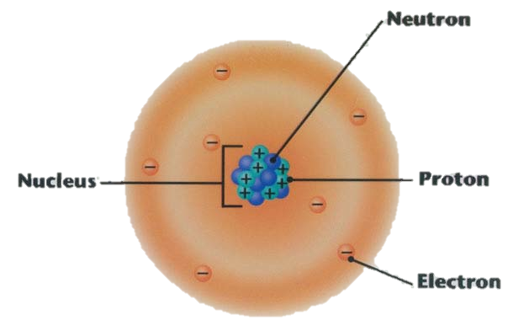
Protons are positively charged (+) and are located in the nucleus.
Neutrons have no charge (neutral) and are located in the nucleus.
Electrons are negatively charged (-) and are located outside orbiting the nucleus.

Write down some examples of different atoms that you know.

Pure Substances
- A pure substance is something which is composed of only ____________of particle.
- Particle: an _________ or ___________
Example:
The Classification of Matter
Elements:
A pure substance that cannot be changed into anything simpler
eg.
- When atoms of only ______kind are grouped together you have an ________. Elements are listed on the periodic table. There are just over ________ different elements in the universe.
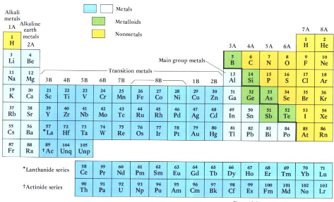
Compounds
- _____________ that consist of _________ or more different types of atoms _____________bonded together to make one type of _____________.
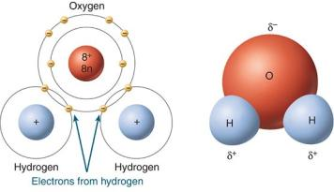
Example: Water H₂0
- Made of __________atoms and ____________ atoms but the only molecule is H₂O

- Only one type of atom
e.g. Mg
- two or more types of
atoms but only one type
of molecule
e.g. H₂O

Mixtures
  - Contain ________ or _________ pure substances
  - Eg. salt dissolved in water
Kool Aid is a mixture because it’s made up of water molecules, sugar molecules, and food colouring molecules
Homogeneous Mixtures:
Made up of substances that are evenly and microscopically mixed together
These are called ____________________ (look like one thing).
Salt water ( _____________Solution)
made of salt molecules and water molecules
Steel ( ______________ Solution)
made of iron atoms, nickel atoms, chromium atoms, carbon atoms
Air ( ____________ solution)
made up of many different types of atoms and molecules such Oxygen, Carbon Dioxide and Nitrogen.

Heterogeneous Mixtures:
  - A mixture that is not uniform in its composition
  - A ______________ is a liquid and solid that doesn’t mix like flour and water
  - A _______________are medium sized particles that don’t settle like fog or milk.
  - A _______________ mixture is a mixture of solids that can be seen. eg.salad

Physical and Chemical Changes
In a physical change no new substances are formed
Physical changes include changes of state.

- liquid to solid: _____________ or Freezing
- solid to liquid: _____________
liquid to gas: _______________ or Boiling
- gas to liquid: _______________
- gas to solid:__________________
- solid to gas: _________________
Kinetic Molecular Theory
  - All matter is made up of tiny particles.
  - Different substances have different particles.
  - The particles are in constant ____________.
  - The more __________ the particles have, the faster they _____________.
  - The attraction between particles _____________ with distance.
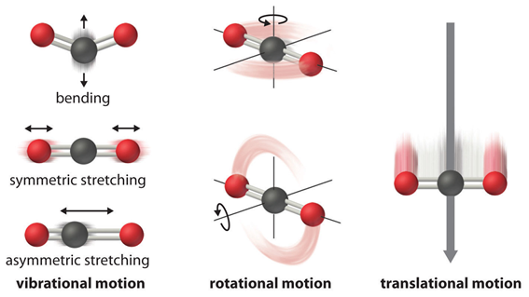
Chemical change results in a _______ substance being produced with __________ chemical and physical __________.
In short, a _______________takes place. e.g. frying an egg, burning

Clues that a Chemical Reaction Might Have Occurred:
      - ____________ change
      - _________ or _________ given off
      - ____________ given off
      - __________ released
      - ____________ forming in a liquid
      - Difficult to __________
- Identifying Chemical and Physical Change
 | Physical | Chemical
Reversible
New substance
Properties
Energy change

Chemical vs Physical Properties

Physical Properties describe a substances

- physical state - solid, liquid or gas

- appearance – ______________ , texture, smell

- density, melting and boiling points

Chemical Properties describe a substances’ behavior in a reaction.

Example = ___________________, poisonous, highly reactive, corrosive,

Observations of matter
Qualitative vs Quantitative

A chemical ___________ means that a chemical __________ has occurred.
In a chemical reaction one or more substances (___________) change to one or more new substances (____________)
Energy is either released OR absorbed in every chemical reaction.
2 H₂ + O₂ 2 H₂O
__________ ___________
Practice – write the word equation
Aluminum reacts with oxygen to form aluminum oxide

In our bodies we use glucose and oxygen to produce carbon dioxide, water and ATP.
Two Types of Chemical Reactions You Know About
_______________: metal reacting with oxygen and water to form rust.
_______________: is the burning of a substance (fuel) in the presence of oxygen. Products are carbon dioxide and water.
- In a chemical reaction atoms rearrange to form new substances.
- HCl + NaHCO₃ → H₂O + CO₂ + NaCl
- the total _________of the reactants is equal to the total mass of the ____________ because no atoms are created or destroyed…only rearranged!
- This is the Law of _______________ of Mass.
A closed system (a sealed container) is needed to prove the Law of Conservation of Mass!
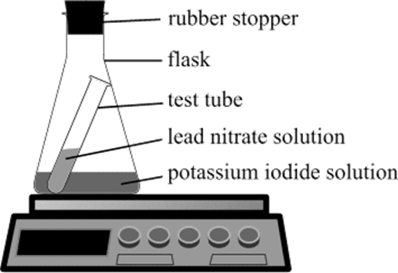

Endothermic vs Exothermic Reactions

All reactions either give off energy or absorb energy.
______________reactions absorb energy and the surroundings can get cooler.
______________ reactions release energy the surroundings get warmer like in combustion and burning.

